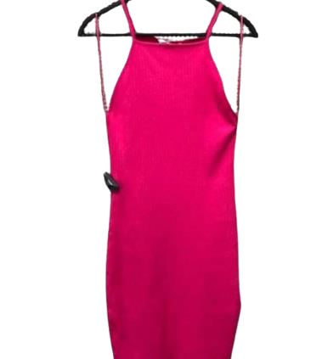
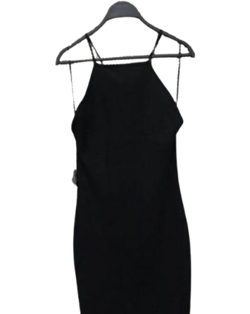
PACKING LIST - ZARA ITEMS

COLOUR | SIZE | QUANTITY | TOTAL
Black | S | 7 500 | 30 000
Black | M | 7 500 | 30 000
Black | L | 7 500 | 30 000
Black | XL | 7 500 | 30 000

COLOUR | SIZE | QUANTITY | TOTAL
FUSHIA | S | 7 500 | 30 000
FUSHIA | M | 7 500 | 30 000
FUSHIA | L | 7 500 | 30 000
FUSHIA | XL | 7 500 | 30 000

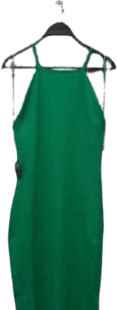
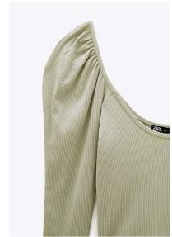
COLOUR | SIZE | QUANTITY | TOTAL
GREEN | S | 7 500 | 30 000
GREEN | M | 7 500 | 30 000
GREEN | L | 7 500 | 30 000
GREEN | XL | 7 500 | 30 000

COLOUR | SIZE | QUANTITY | TOTAL
UNIQ | S | 2 750 | 11 000
UNIQ | M | 2 750 | 11 000
UNIQ | L | 2 750 | 11 000
UNIQ | XL | 2 750 | 11 000

